
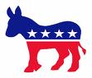
WEBQUEST : The American Election

Vs.

→ Go to the Internet site: http://obama-mccain.info and complete the questions.

- TIME LEFT: ............. days ..............hours ..............minutes.
- ELECTION DAY: .................................................................................
- COMPARISONS:

 |   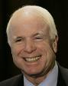 | 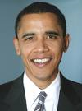  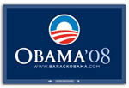
Political party
Age
Date of birth
Place of birth
Ancestry
Siblings
Spouses
Children
Car
Heroes
Pets
Favourite food
Favourite music
Favourite movies
Favourite TV show

- NATIONAL CONVENTIONS (date + place):



e- ISSUE COMPARISONS: you are going to compare Obama’ s and McCain’ s points of view concerning different issues (= themes). Say if they are FOR or AGAINST them.

 | McCain | Obama
Abortion
Capital Punishment ( death penalty )
Education ( school vouchers )
Guantanamo ( interrogation methods )
Gun Control ( assault /concealed weapons )
Immigration ( legalization )
Iraq ( troop increase )
Same-sex issues ( marriage )

Now write a paragraph about their points of view (choose 4 issues).

→ Use the following vocabulary:

BOTH ... | ...WHEREAS ...

Yes | No
to be FOR ...  to be IN FAVOUR OF ...  to SUPPORT ... | to be AGAINST ...  to be OPPOSED TO ...  to OPPOSE ...

........................................................................................................................................................................................................................................................................................................................................................................................................................................
........................................................................................................................................................................................................................................................................................................................................................................................................................................
........................................................................................................................................................................................................................................................................................................................................................................................................................................
........................................................................................................................................................................................................................................................................................................................................................................................................................................
........................................................................................................................................................................................................................................................................................................................................................................................................................................

